**Technical Documentation for Library Application**

**Product Name:** Library Application

**Phase**: completed

**Date**: 05/10/2023

Product Overview

This is a simple Library web application implemented using Spring Framework. This project includes front-end, a database layer and the logic that brings the data that you store in database tables into the front end.

**Product Objectives**

The Library Application simulates a real library where users can get a list of all the books, add a new book, find a book, and remove a book from the library.

**Product Features**

The Library Application is implemented using the Spring Framework and a database layer and the logic that brings the data that you store in database tables into the front end.

**Feature/Element 1**

Homepage with welcome message

**Element 2**

A menu page shows all the application’s functions.

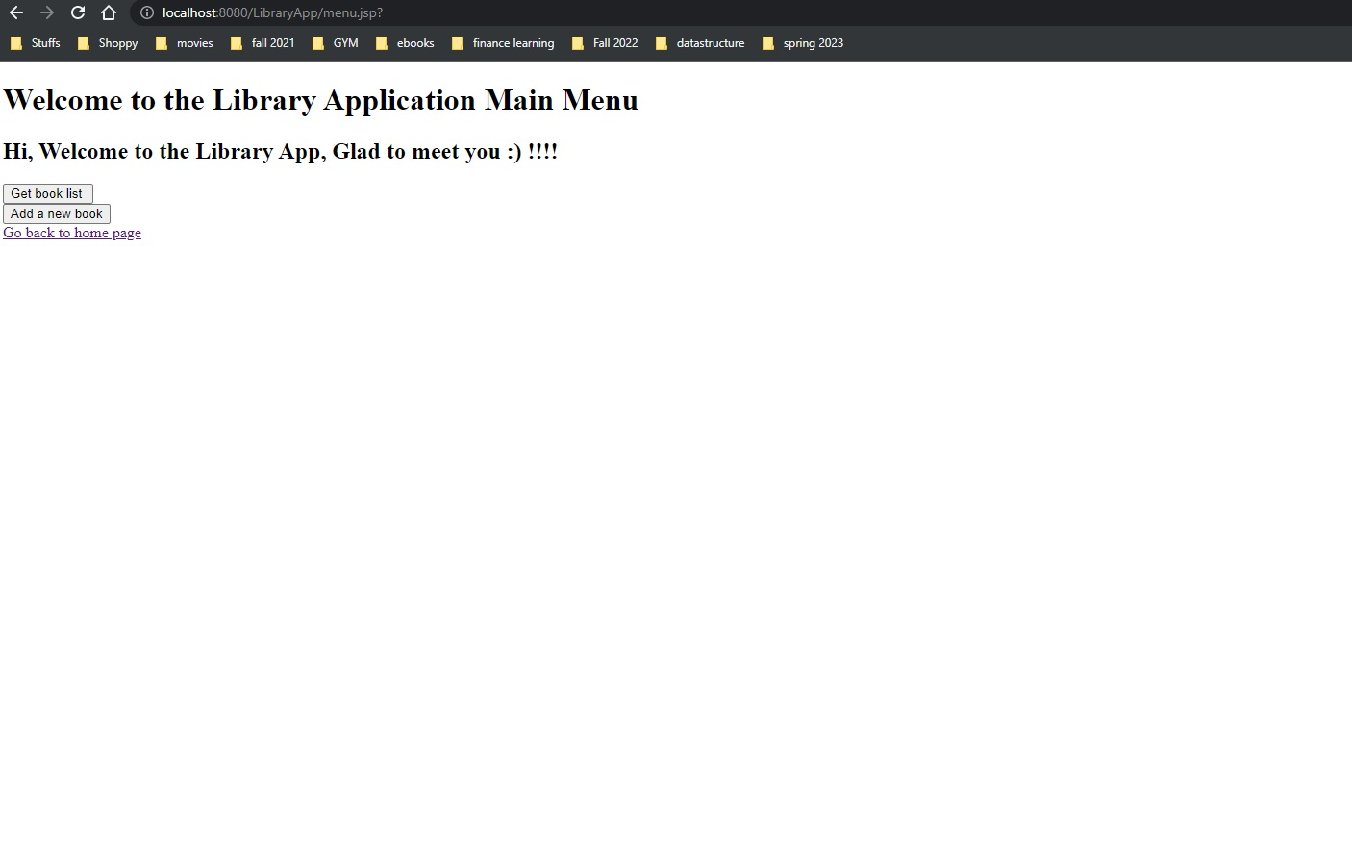

**Element 3**

Book Listing

**Database model using MySQL**

